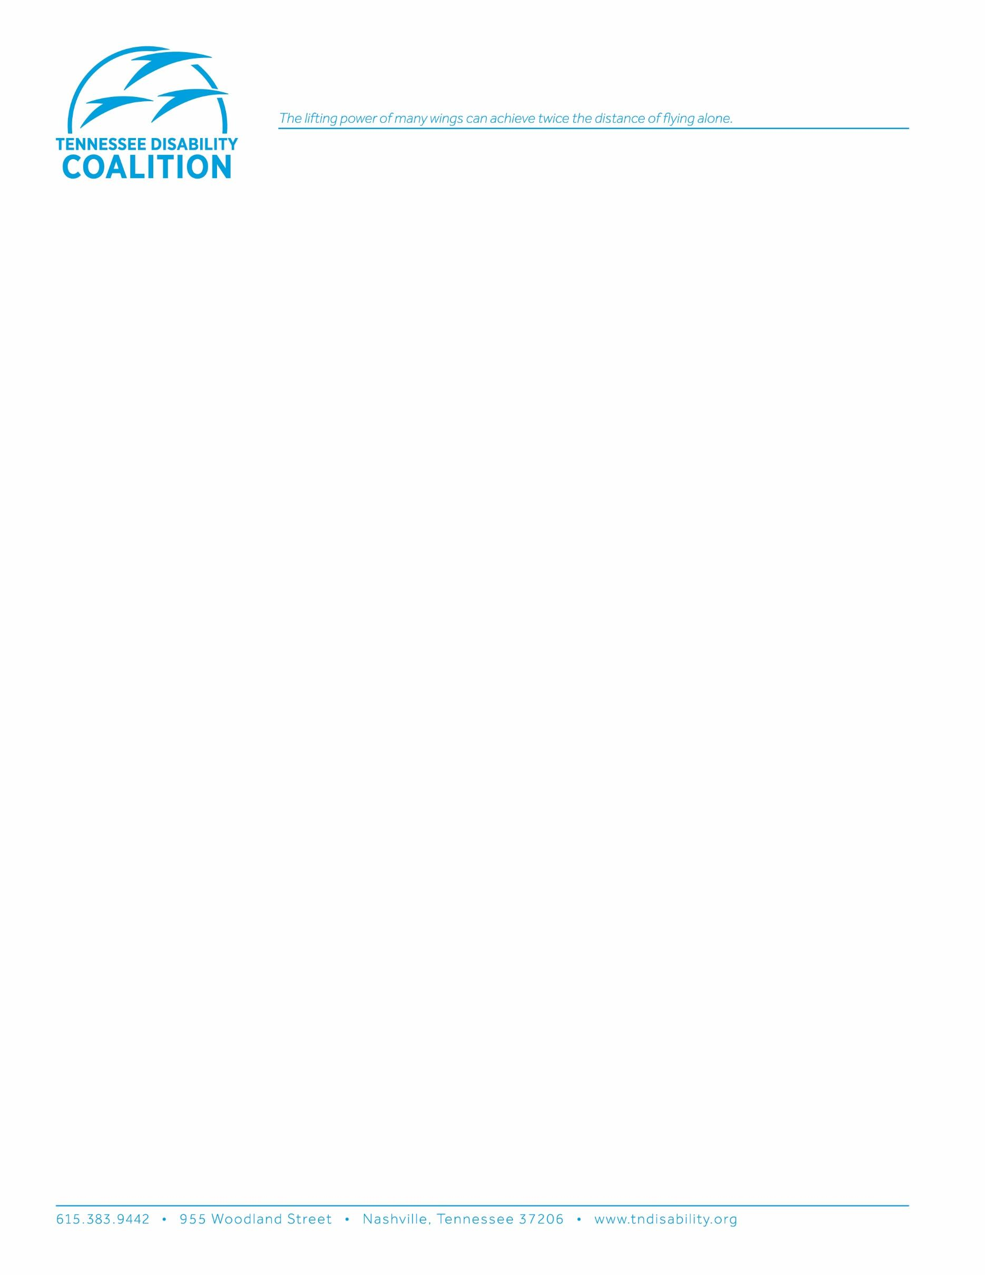

June 9, 2025

Filed to [www.regulations.gov](http://www.regulations.gov/) under [DOE-HQ-2025-0015](https://www.regulations.gov/document/DOE-HQ-2025-0015-0001) and [DOE-HQ-2025-0024](https://www.regulations.gov/document/DOE-HQ-2025-0024-0001)

Emailed to [DOEGeneralCounsel@hq.doe.gov](mailto:DOEGeneralCounsel@hq.doe.gov)

Department of Energy

Office of Civil Rights and EEO

1000 Independence Avenue SW, Room 5B-168

Washington, DC 20585

Department of Energy

Office of Minority Economic Impact

1000 Independence Avenue SW

Washington DC 20585

[DOE-HQ-2025-0024](https://www.federalregister.gov/documents/2025/05/16/2025-08593/rescinding-regulations-related-to-nondiscrimination-in-federally-assisted-programs-or-activities) Nondiscrimination

[DOE-HQ-2025-0015](https://www.federalregister.gov/documents/2025/05/16/2025-08535/rescinding-new-construction-requirements-related-to-nondiscrimination-in-federally-assisted-programs) New Construction Requirements

To Whom It May Concern:

I am writing on behalf of the Tennessee Disability Coalition (TDC). The Coalition is an alliance of almost 50 groups and organizations in Tennessee that have joined to promote the full and equal participation of men, women and children with disabilities in all aspects of life. The core purpose of the Coalition is to work for systems change and to advocate public policies that ensure every person with a disability has the freedom and opportunity to exercise individual decisions that affect their own lives, welfare and personal dignity.

Policies that promote self-determination, independence, empowerment, and integration of children and adults with disabilities in all aspects of society are endorsed by the Coalition. Special emphasis is given to enhancing civil rights and quality of life and upholding the values of Section 504 and the Americans with Disabilities Act.

Access to the built environment is fundamental. Individuals can only achieve self-determination, independence, economic self-sufficiency, and real lives if they are able to function in all places and in all aspects of their communities.

**It is for this reason that TDC is providing this adverse comment opposing the direct final rules at Docket Numbers DOE-HQ-2025-0015 and DOE-HQ-2025-0024.**

The proposed rules would rescind critical portions of the Department of Energy (DOE)’s regulations implementing Section 504 of the Rehabilitation Act. Number 2025-0015 would rescind 10 C.F.R. § 1040.73, which requires recipients to ensure that new construction and alteration is fully accessible to people with disabilities. Number 2025-0024 would rescind portions of DOE’s program access rule for existing facilities at 10 C.F.R. § 1040.72(c) & (d), including the requirement to make a transition plan to eliminate access barriers in these existing facilities.

People with disabilities, whether employees, visitors, partners, or contractors, are discriminated against when the built environment is not accessible. When construction is accessible, it includes things like:

* Accessible parking spaces that allow deployment of a van’s wheelchair lift
* An accessible route from a parking lot to the entrance  -- wide space, nothing obstructing the route (e.g., planters, trash buckets),no stairs/steps
* Entrance is zero step - no stairs
* Accessible paths once inside a building -- into and out of rooms
* Counters that people in mobility devices can reach
* Restrooms that are simply big enough for someone with a mobility device to use privately
* Hardware -- single-handle lever controls; touchless, or motion-activated
* Emergency alerting devices with a loud tone, flashing lights and/or vibrations

The proposed rules should not be adopted. They run contrary to intent of Section 504. They are also unlawful. “Direct final rules” must be routine or noncontroversial. The proposed rule changes are neither. Instead, the proposals would delete foundational provisions implementing Section 504 in contradiction of Congress’s clear understanding of the law.

“[E]limination of architectural barriers was one of the central aims of the [Rehabilitation] Act.” *Alexander v. Choate*, 469 U.S. 287, 297 (1985). The requirement that newly constructed and altered facilities be fully accessible to people with disabilities, as measured by applicable access standards, is central to this purpose. As important is the requirement that recipients of federal funds undertake careful accessibility planning to remove barriers in existing buildings.

In 2025 it is unconscionable that inaccessible new construction would be allowed. The proposed rules would allow this. The rules would also upend decades of reliance on established accessibility standards, creating conflicts with other statutory and regulatory standards.

*The Proposed Rules Would Destroy Balanced Rulemaking Approved by Congress*

The rules at issue date back to the coordination regulations adopted by the Department of Health, Education, and Welfare (HEW) in 1978. These rules were intended to establish **minimum standards** for implementing Section 504 across the federal government and were based on HEW’s Final Rule for its own recipients finalized in 1977.

In adopting the 1977 and 1978 rules, HEW consulted extensively with Congress and engaged in multiple rounds of notice and public comment. The final rules carefully balanced the challenge of addressing barriers to people with disabilities in existing buildings with the opportunity for new construction and alterations to achieve greater accessibility going forward.

The compromise reached – which has been adopted by more than 80 federal agencies – was and still is to allow some flexibility with respect to existing buildings, while requiring new facilities to be fully accessible as measured by access standards. Over time, this approach advances Section 504’s goal of reaching a more accessible environment for people with disabilities.

Congress has repeatedly reviewed and approved the regulatory standards that DOE now seeks to delete, giving them the force of law. *Rail Corp. v. Darrone*, 465 U.S. 624, 635 nn.15 & 16 (1984). Federal courts have enforced the rules for decades. DOE may not lawfully eliminate foundational rules for the implementation of Section 504.

*The Proposed Rules Would Undermine Access Standards and Create Conflicts*

Compliance with access standards in new construction and alterations is critical to advancing the goals of Section 504. The deletion of the regulatory reference to the Uniform Federal Accessibility Standards as a measure of compliance would directly undermine the goals of Section 504. Access standards are key to making new construction and alterations accessible. Architects and contractors need a comprehensive set of design rules to ensure that new construction and alterations are built to be fully accessible to people with disabilities. Accessibility is often a matter of inches, making the difference between inclusion and exclusion of people with disabilities. Without access standards, we will never reach the fully inclusive society intended by Congress in enacting and reenacting Section 504.

The rules would also create conflicting enforcement standards: recipients of federal financial assistance from the DOE include many entities that receive funding from other federal departments and agencies, and/or that are subject to the requirements of the ADA. These recipients would be required to comply with access standards due to their other funding or under the ADA but would remain open to liability under the general nondiscrimination language at section 1040.71.

*The Rulemaking is Unlawful and Must Be Withdrawn*

The careful compromise reached by agencies and Congress – to require that new construction and alteration be fully accessible, while imposing a more flexible standard for existing facilities – would be destroyed by the proposed “direct final rules.” Ensuring that new construction and alterations are fully accessible to people with disabilities is critical to advancing the goals of Section 504 of the Rehabilitation Act.

The rulemaking is unlawful and must be withdrawn.

Respectfully,

Sarah Sampson

Executive Director