Important SSA Issues for Transition Aged Youth

Two types of disability benefits: Supplemental Security Income (SSI) and Social Security Disability Insurance (SSDI)

SSI is a needs-based program. Maximum benefit amount is $841/month. If a beneficiary is not paying their share of household expenses, SSA reduces the amount by 1/3. SSA looks at income and resources to decide eligibility. TennCare Medicaid comes with SSI.

SSDI benefit is based on work history. If you are at least 18 years old and disabled as a child, you may qualify to draw off a parent’s record. Parents must have worked and earned enough credits and now be retired, deceased or disabled themselves. Medicare comes with SSDI.

Age 18 Redetermination: If you received SSI as a child, you must go thru a disability review when you turn 18. The adult definition of disability is harder to meet. If found not disabled, SSA will stop your SSI check and Medicaid. UNLESS…

Section 301 (Vocational Rehab and IEP): Protection for people who do not meet the adult definition of disability when they go thru a medical review. SSI can continue if you currently have an Individualized Education Program (IEP) in high school or you are participating in the Vocational Rehabilitation program (have an active Individualized Plan for Employment - IPE). If you have an IEP or IPE, you can keep getting SSI and Medicaid until you complete the program.

Representative Payee: Someone who receives and manages SS benefits on behalf of another person who has been determined incapable. This is different from legal guardianship.

Legal Adulthood: Turning 18 means a student is legally an adult, regardless of disability.

Marriage: If you are getting SSI and marry someone who has other income, your SSI will be reduced. If you are getting SSDI as a disabled adult child and get married, you will lose your benefit unless you marry someone who is also getting SSDI (not SSI).

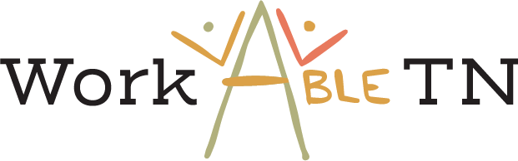
(615) 383-9442

