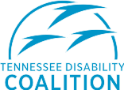
Contact: Tom Jedlowski
Director of Communications
(615) 972-4147
tom_j@tndisability.org

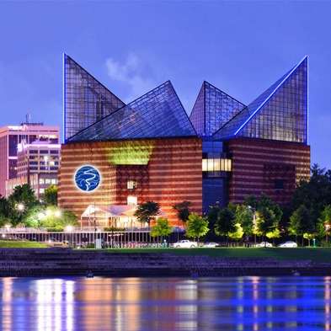
(L)Henley St. Bridge, Knoxville, (R)Tennessee Aquarium, Chattanooga
East Tennesseans Celebrate Success
& Importance of Advocacy in Disability Community;
Dollywood’s Wildwood Tree, Henley St. Bridge , Tennessee Aquarium, and Landmarks Across Tennessee Lighting Up “Coalition Blue” in Support of Disability Advocacy Day & Americans with Disabilities Act

Nashville, Tenn., March 2nd, 2022 — The Tennessee Disability Coalition (TDC), an alliance of over 40-member organizations and individuals advocating for 1.6 million Tennesseans with disabilities today announced March 11th as the second-annual Disability Advocacy Day in Tenn. Now in its second year, Joint House Resolution 188, introduced by Representative Sam Whitson of District 65, Franklin, honors “the importance of advocacy in the lives of Tennesseans with disabilities and in improving access to equal opportunities across the state of Tennessee.”
Tennesseans with disabilities experience disparate access to the same basic education, housing, transportation, and healthcare as state residents without disability. Outside of a pandemic, self and collective advocacy is critical to ensuring access to essential supports and services. Amid the pandemic, with procedures and policies in constant flux, and state COVID-19 deaths eclipsing 25,000; Tennesseans with disabilities continue to use their voices to speak up for basic services, and speak out against policies that infringe on civil rights and other legal protections afforded under the Americans With Disabilities Act. Consequently, this often-marginalized and overlooked community has made a formidable impact on state policy. For a comprehensive list of achievements including the Tennessee Disability Act, the Katie Beckett Program, and many more, please visit www.tndisability.org/disability-advocacy-day.
“People with disabilities learn very early that advocacy is the only way to tackle the barriers they face in an ‘able’ world,” said Tennessee Disability Coalition Executive Director, Carol Westlake. “We learned decades ago that we have to build community, work together, and be clear about what’s needed. It takes advocacy to achieve the basic level of access, inclusion, and support that others take for granted. We have to stand up, speak up and follow up. And we have to stick together. We’re grateful to the 112th legislative session, and to the dozens of landmarks across the state lighting up blue to support Disability Advocacy Day on March 11th and the Americans with Disabilities Act.”
Four locations in East Tenn., and 20+ across the state, will light up “Coalition Blue” in support, solidarity, and recognition of the Americans with Disabilities Act, and successful advocacy by the disability community of Tenn.
East TN:
Dollywood, Wildwood Tree – Pigeon Forge
Henley Street Pedestrian Bridge – Knoxville
Liberty Tower - Chattanooga
Tennessee Aquarium – Chattanooga

Middle TN:
Adventure Science Center Pyramid – Nashville
Bicentennial Capitol Mall State Park – Nashville
City Hall – Nashville
Customs House Museum & Cultural Center - Clarksville
Korean Veterans Memorial Bridge – Nashville
Nashville International Airport – Nashville
Nissan Stadium – Nashville
State Capital Cupola – Nashville

West TN:
Big River Crossing – Memphis
Carl Perkins Civic Center – Jackson
City Hall – Jackson
Eiffel Tower Replica – Paris
Hernando DeSoto Bridge – Memphis
Liberty Bowl Stadium – Memphis
University of Memphis – Memphis

For organizations without lighting capacities, or to support Disability Advocacy Day as an individual, community members are encouraged to wear blue, and a digital library of graphics, messaging, associated hashtags, and other resources are available on the Tennessee Disability Coalition’s website. Graphics include pre-sized social images for Twitter, Facebook, and Instagram. It also includes pre-sized wallpaper graphics for iPhone, iPad, and Android mobile devices for individual supporters to “light up” in support, and spark conversation.
For more information about Disability Advocacy Day or the Tennessee Disability Coalition please visit www.tndisability.org.

About the Tennessee Disability Coalition: The Tennessee Disability Coalition is a 501(c)3 nonprofit alliance of over 40+ member organizations and individuals joined to promote the full and equal participation of people with disabilities in all aspects of life. With programs, public policy, and purpose we collectively advocate for self-determination, independence, empowerment, and inclusion for people with disabilities in areas such as accessibility, education, healthcare, housing, and voting rights. For more information about the Tennessee Disability Coalition, please visit http://www.tndisability.org, email coalition@tndisability.org, or call (615) 927-3694

###

